I included quite a bit of information here. I don’t want this article to overshadow the information on the international conference, yet we do want to give information to interested members. Let me know what you think.

European Regional Conference 2016: Challenging Vocation in Higher Education
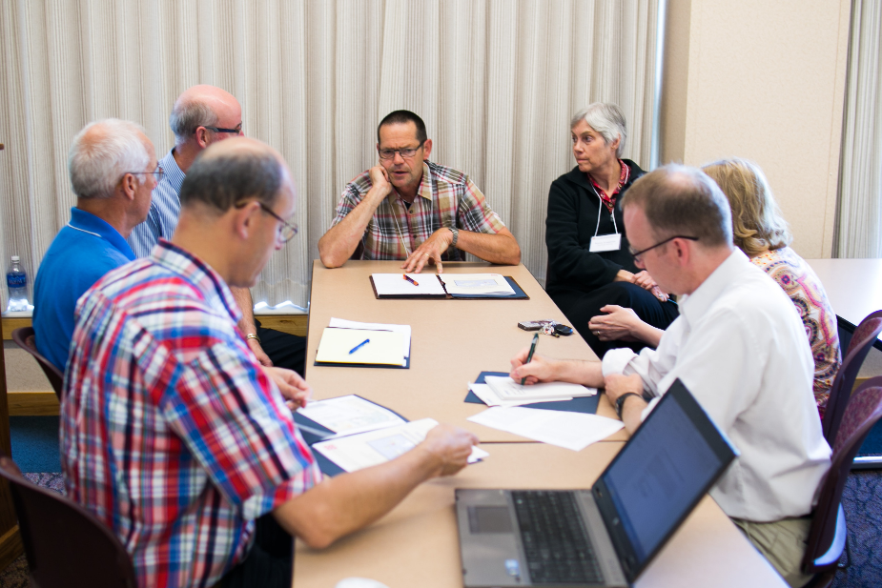
QUICK FACTS
- Dates: April 12-15, 2015
- Location: The Beukenhof, Biezenmortal, the Netherlands
- Theme: Challenging Vocation in Higher Education (see details below)
- Host Institutions: Christelijke Hogeschool Ede, Driestar Educatief, Protestant Theological University; VIAA Zwolle
- Deadline to Submit Proposals: November 1, 2015 (see details below)
- Contact: Use iapche2016.org/contact or email Lydia Bor at e.l.bor@driestar-educatief.nl

THEME
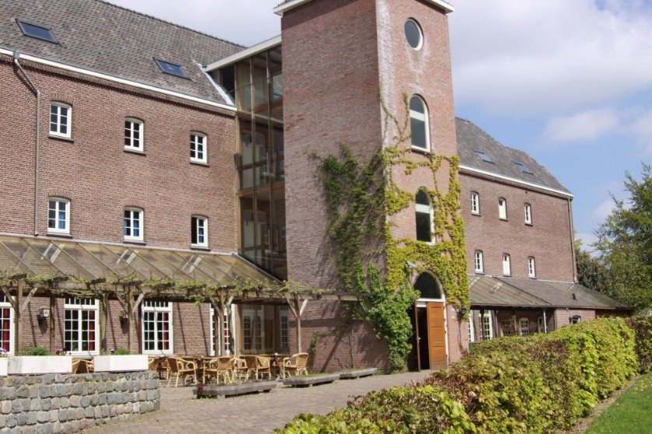
The conference focuses on the notion of Christian vocation. While the notion of every believer being uniquely called to serve God in their daily work has gradually disappeared, this seems to have left a spiritual and ethical void in professional practices. In addition, while the identification of divine vocation with work itself has rightly been theologically contested, the notion of vocation is still an apt response to the urgent need for Christians who serve in our complex world to hear the voice of God and act with wisdom and discernment. Given the aim of Christian educators to foster character development, spiritual and moral formation, responsible citizenship and reflective practice, clarifying what is meant by the concept of ‘vocation’ and how this applies to practice remains an important task for research. This conference will reflect on this task and create a space for sharing good practices from our own institutions.
The previous IAPCHE Europe conference in 2009 (also held in Biezenmortel) explored the similar theme of ‘Bridging the gap. Connecting Christian Faith and Professional Practice’. It soon became clear that there was still much that remained unexplored. This time, the conference will centre on the identity of Christian professionals and the formation processes that foster their future vocations. Discussions will therefore draw upon theologies of work and the distinguishing features of the Christian worker. This will include the relationship between professional practices and the Christian message of love and how such practices are introduced in universities. Economics and politics also have an pronounced impact on work and study and so their effects on how we inspire students to grow in their vocations will also be discussed.

TRACKS
The program will be split into three tracks, each covering a different aspect of the theme described above.
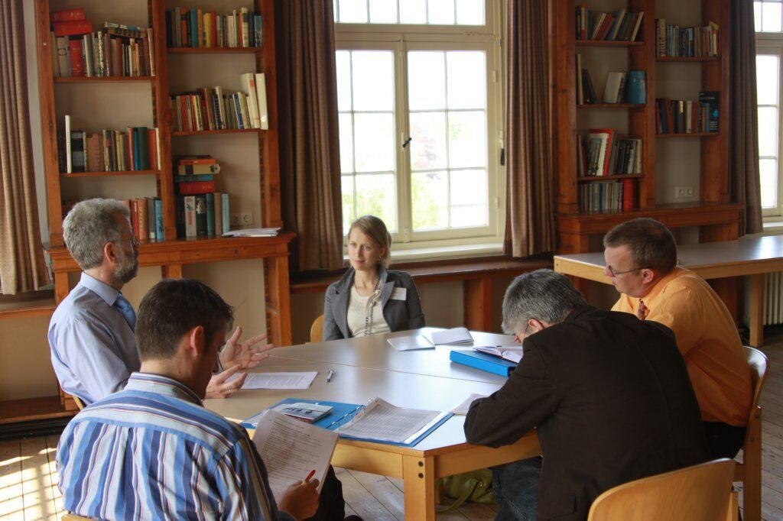
- Academic reflection on the concept of vocation. This track will reflect on theologies of work and profession, on the nature of vocation and on Christian professional identity. This track will have two main foci. The first will draw upon the work of established theologians of the nature of a Christian vocation. The second will take account of the contextual nature of vocation to clarify how societal trends affect professionalism in Christian Higher Education, most notably the tension between control and accountability and the place of professional values.
- The Development of Christian professionals within the university and within their professional environment. This track will seek to understand the meaning of identity and character development for Christian professionals. What attitudes and character traits should students and alumni develop? This track will therefore pay attention to psychological processes and how they can be informed by biblical standards.
- Revitalising vocation-centred education practices in Europe. This track will look to sketch the ideal environment for the development of Christian professionals. It will provide space to discuss principals for creating a Christian pedagogical environment by presenting well-documented, theoretically underpinned good practices. A further aspect of this track will be to reflect on the conditions necessary for lifelong learning among Christian professionals. What can universities do for professionals? How can educators foster a sense of Christian vocation?

CALL FOR PAPERS
Requirements for proposals
- Format
If you wish to submit a paper for the breakout sessions or the workshops, please use this format / Type of presentation:
– Paper presentations (15 minutes)
– Workshop (60 minutes)
- Content
A short description (300-500 words) of what you would like to present. References in APA style can be added and do not count towards word count.
- If you would like to contribute to a breakout session by presenting your research, please give the problem statement, method, results and discussion.
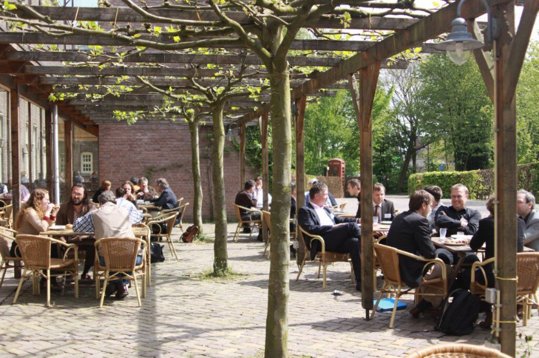
- If you would like to contribute to a breakout sessions by means of presenting a good practice, please mention the situation where the good practice is located, a description about what is done including actors and their interests, and a discussion of why this practice qualifies as an example of good practice.
- If you would like to contribute a workshop to the conference, please explain how you will use the 60 minutes session for collective learning.
- Details for conference manual/website
- Abstract of 50 words to be used for the conference description.
- Curriculum Vitae of max 80 words (written, not listed). Please follow the example from the proceedings of the previous conference:
Bram de Muynck (1961) lectures at Driestar Christian University in Gouda the Netherlands and holds a chair of Christian teaching. He directs a research project on the development of spirituality and worldview in teachers training. He has published on identity of Christian schools, spirituality of teachers, counseling of teachers, behaviour problems in the family and at school, on youth culture and education and on shaping Christian principles in everyday education.
- Mailing Address
- Institution (name and full address)
- Intention to prepare a paper for the Journal ‘Christian Higher Education’ yes/no
SUBMISSIONS
- Submissions can be sent to the office of the conference IAPCHE-EU2016, info@iapche2016.org, before November 1, 2015
- Acceptance messages will be sent by December 1, 2015.
